MINI PROJECT REPORT
HOSPITAL PATIENT MANAGEMENT SYSTEM
AIM: Hospital Patient Management System Using Scilab.
INTRODUCTION:
Hospitals handle a large number of patients daily, making it necessary to maintain proper patient records. Manual record keeping can lead to errors, data loss, and difficulty in tracking patient information. Therefore, computer-based systems are used to manage patient records efficiently.
Scilab is a powerful tool that supports data storage using matrices and structures. In this project, patient data is stored and displayed using Scilab commands. The system helps users add patient details, store diagnosis information, calculate fees, and generate summaries.
This project demonstrates how simple programming can be used in real-world healthcare systems.
OBJECTIVES:
The main objectives of this project are:
- To create a Hospital Patient Management System
- To store patient details
- To track patient diagnosis
- To store consultation fees
- To display patient records
- To generate a summary of patient information
- To understand data storage using matrices
- To simulate real-world healthcare management
SOFTWARE REQUIREMENTS:
The following tools were used:
- Software: Scilab
- Operating System: Windows
- Hardware: Laptop
Knowledge Required:
- Basic Programming Concepts
- Basic Scilab Commands
- Understanding of Data Storage
THEORY:

Patient Management System:
A Patient Management System is used to store, manage, and retrieve patient records. It helps hospitals maintain organized records of patients.
DATA STORAGE USING MATRICES:
Matrices are used to store numerical data such as:
- Patient ID
- Age
- Fees
Example:
Patient Data Matrix:
ID Age Fees
1 30 500
2 45 900
STRUCTURES IN Scilab:
Structures help store different types of data such as:
- Name (text)
- Diagnosis (text)
- Age (number)
They make data storage more organized.
USER INTERFACE (UI):
A simple user interface allows users to:
- Enter patient details
- View stored records
- Display summaries
This improves usability.
ALGORITHM:
Step 1: Start the program
Step 2: Clear screen and variables
Step 3: Enter number of patients
Step 4: Enter patient details
- Patient Name
- Age
- Diagnosis
- Fees
Step 5: Store patient details
Step 6: Display stored records
Step 7: Generate summary
Step 8: Stop the program
FLOWCHART:
Start
↓
Clear Screen
↓
Enter Patient Details
↓
Store Data
↓
Display Records
↓
Generate Summary
↓
Stop

PROGRAM CODE:
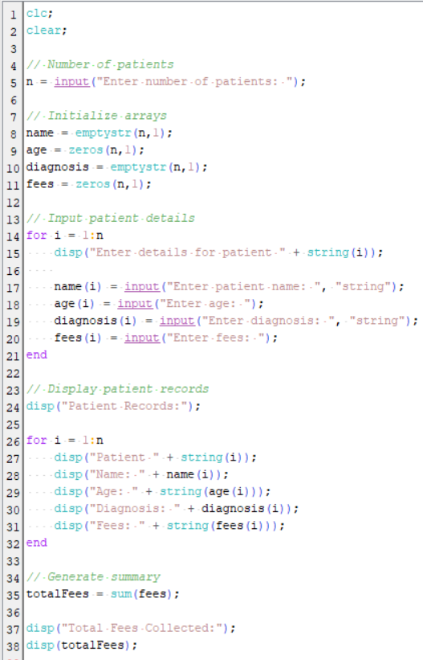
OUTPUT:
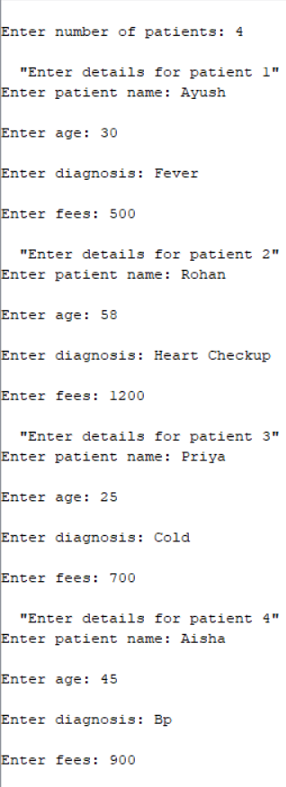
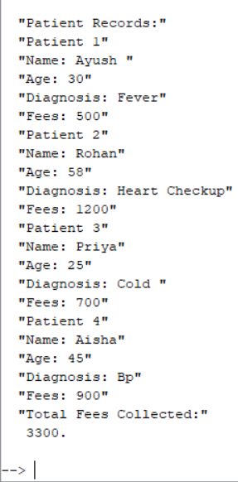

ADVANTAGES:
- Easy record management
- Saves time
- Reduces paperwork
- Improves accuracy
- Useful in healthcare systems
APPLICATIONS:
This system can be used in:
- Hospitals
- Clinics
- Medical Centers
- Healthcare Management Systems
- Patient Record Systems
LIMITATIONS:
- Basic system without advanced features
- Requires manual data entry
- No database connection
- Limited to simple records
FUTURE ENHANCEMENTS:
This project can be improved by:
- Adding patient ID system
- Creating graphical user interface (GUI)
- Connecting to database
- Adding search option
- Generating printable reports
- Adding appointment scheduling
REAL WORLD USE:
Hospital Patient Management Systems are widely used in:
- Government Hospitals
- Private Hospitals
- Diagnostic Centers
- Healthcare Clinics
They help maintain patient records and improve hospital efficiency.
CONCLUSION:
This mini project successfully demonstrates a Hospital Patient Management System using Scilab. It allows storing patient details, tracking diagnosis, managing fees, and generating summaries. The project shows how basic programming concepts like data storage and user input can be used to create useful real-world healthcare applications.
SUBMITTED BY:
ALIZA AKBAR (202410101150222)

